QUILL & ARROW, LLP
Kevin Y. Jacobson, Esq. (SBN 320532)
kjacobson@quillarrowlaw.com
Harry Terzian, Esq. (SBN 347701)
hterzian@quillarrowlaw.com
Siyun Yang, Esq. (SBN 343864)
syang@quillarrowlaw.com
e-service@quillarrowlaw.com
10880 Wilshire Blvd., Suite. 1600
Los Angeles, CA, 90024
Telephone: (310) 933-4271
Facsimile: (310) 889-0645

Attorneys for Plaintiff,
<< Matter.CustomField.PlaintiffsNameShort >>

superior court of the state of california
county of << Matter.CustomField.County >>
<< Matter.CustomField.PlaintiffsFullLegalName >>,  Plaintiff,  vs.  GENERAL MOTORS LLC, a Delaware Limited Liability Company, and DOES 1 through 10, inclusive,  Defendants. | Case No.: << Matter.CustomField.CaseNumber >>  Assigned for all purposes to Hon. << Matter.CustomField.Judge >>in Dept. << Matter.CustomField.CourtDepartment >>  DECLARATION OF SIYUN YANG IN SUPPORT OF PLAINTIFF’S OPPOSITION TO DEFENDANT GENERAL MOTORS LLC’S MOTION TO STRIKE PUNITIVE DAMAGES FROM PLAINTIFF’S FIRST AMENDED COMPLAINT  [Filed concurrently with Plaintiff’s Opposition to Defendant’s Motion to Strike Punitive Damages from Plaintiff’s First Amended Complaint]  HEARING:  Date: November 13, 2023  Time: 8:30 a.m.  Dept.: << Matter.CustomField.CourtDepartment >>  Complaint Filed: << Matter.CustomField.DateMatterFiled >>  FAC Filed: July 5, 2023  Trial Date: None Set

DECLARATION OF SIYUN YANG

I, Siyun Yang, declare as follows:
- I am an attorney duly licensed to practice before all of the courts of the State of California. I am an attorney at the law firm of Quill & Arrow, LLP, counsel of record for Plaintiff, << Matter.CustomField.PlaintiffsNameShort >> (“Plaintiff”) in this matter.
- I have personal knowledge of the following facts, and, if called to testify regarding those matters, I could and would competently testify thereto.
- This declaration is submitted in support of Plaintiff’s Opposition to Defendant, General Motors LLC’s (“Defendant”) Motion to Strike Punitive Damages from Plaintiff’s First Amended Complaint.
- On July 21, 2023, the parties telephonically met and conferred on the fourth cause of action and punitive damages in Plaintiff’s First Amended Complaint. However, the parties were unable to come to a resolution after the discussion.

I declare under penalty of perjury under the laws of the State of California that the foregoing is true and correct.

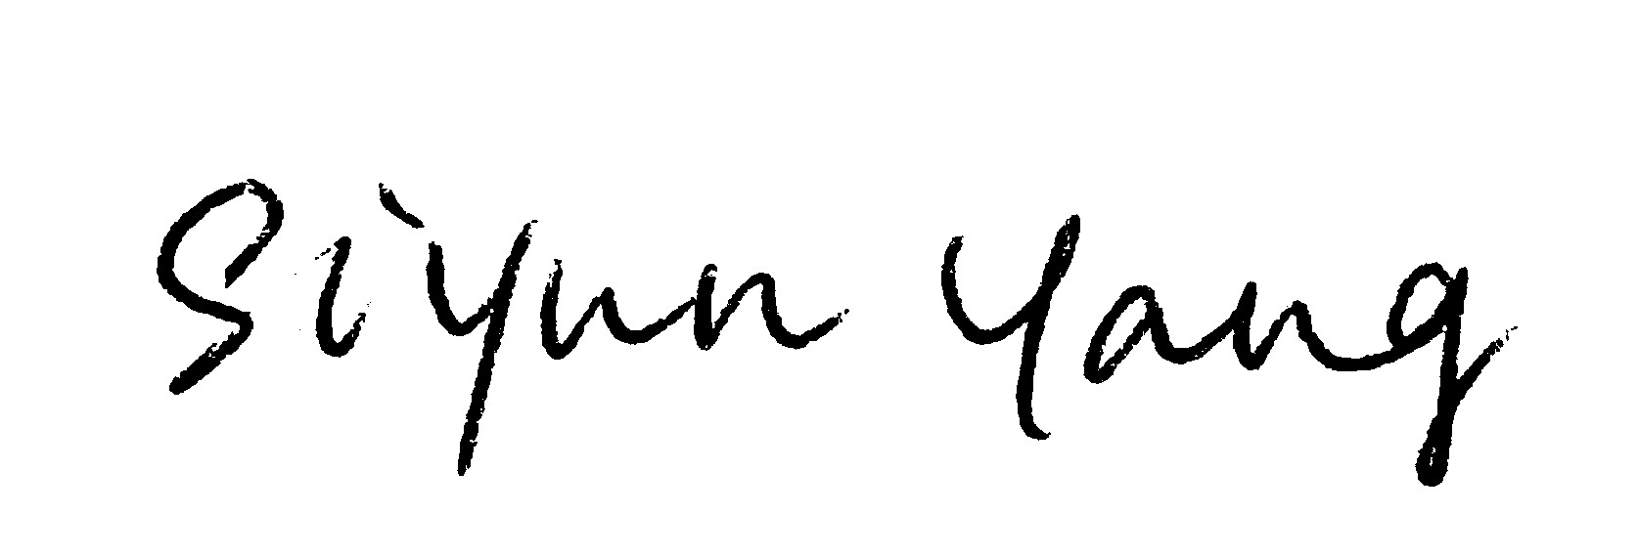
Dated: February 26, 2024

________________________
Siyun Yang, Esq.

PROOF OF SERVICE

I am employed in the County of Los Angeles, State of California. I am over the age of 18 and not a party to the within action. My business address is 10880 Wilshire Blvd., Suite. 1600, Los Angeles, CA, 90024.

On February 26, 2024, I served the following document(s) described as:

DECLARATION OF SIYUN YANG IN SUPPORT OF PLAINTIFF’S OPPOSITION TO DEFENDANT GENERAL MOTORS LLC’S MOTION TO STRIKE PUNITIVE DAMAGES FROM PLAINTIFF’S FIRST AMENDED COMPLAINT

That document was served on parties herein in this proceeding by placing true copies of the original in enclosed, sealed envelope(s) addressed as follows:

SEE ATTACHED SERVICE LIST

[] (BY MAIL) I am “readily familiar” with the practices of Quill & Arrow, LLP, in collecting and processing correspondence and documents for mailing. Under that practice, documents for mailing would be deposited with the US Postal Service on that same day this affidavit is signed with postage fully prepaid at Los Angeles, California in the ordinary course of business. I am aware that on motion of the party served, service is presumed invalid if the postal cancellation date is more than 1-day after the day of deposit for mailing the affidavit. [CCP § 1013]

[] (BY OVERNIGHT MAIL) I am “readily familiar” with the practices of the Quill & Arrow, LLP, for collection and processing of documents for mailing via overnight delivery. I caused such document(s) to be placed in a sealed envelope designated by the overnight service carrier, addressed to the person(s) on whom it is to be served pursuant to the attached service list, and deposited said envelope in a box or other facility regularly maintained by the overnight service carrier with delivery fees paid or provided for. [CCP § 1013(c)]

[X] (BY ELECTRONIC MAIL) I caused the document(s) to be transmitted by electronic mail to the e-mail addresses for each party indicated on the attached service list.

[] (BY PERSONAL DELIVERY) I caused to be delivered such envelope by hand to the addressee at the address indicated on the attached service list.

I declare under penalty of perjury under the laws of the State of California that the foregoing is true and correct.

Executed on February 26, 2024.

/s/Jasmine Perez
Jasmine Perez
SERVICE LIST

Jonathan M. Shugart, Esq.  jshugart@erskinelaw.com  eservice-ca@erskinelaw.com  THE ERSKINE LAW GROUP, PC.  1592 N. Batavia St., Suite 1A  Orange, CA 92867 | Counsel for Defendants

